
Tripoli Motor Testing Division
223 NC Highway 54 West
Chapel Hill, NC 27514
(919) 357 5681 (c)
October 18, 2021

Gary Rosenfield
RCS Rocket Motor Components, Inc.
2113 West 850 North Street
Cedar City, UT 84721

Dear Mr. Rosenfield,

The Aerotech J615ST-20A RMS motor was tested on October 16, 2021 and is in compliance with NFPA 1125. The motor is certified for hobby rocketry use by the members of the Tripoli Rocketry Association and all approving organizations with reciprocal certifying agreements.

Motor Manufacturer Aerotech Division, RCS Rocket Motor Components
Manufacturer’s Designation J615ST-20A RMS [uses the 54/852 hardware]
Propellant Super Thunder
TMT Nomenclature 745 J615

Diameter 2.125” 53.98 mm
Overall Length 9.466” 240.43 mm
Length Inside 9.094” 230.98 mm
Length Outside 0.372” 9.45 mm

Loaded Mass 1.768 lb 801.74 g
Propellant Mass 0.817 lb* 370.5 g*
Burnout Mass 0.896 lb 406.55 g
* data provided by manufacturer

Burn time 1.199 ± 0.046 sec

Total Impulse 167.58 ± 3.19 lbf.s 745.45 ± 14.20 N.s
Max Impulse 209.66 ± 27.77 lbf 933.94 ± 123.52 N
Average Impulse 138.27 ± 5.41 lbf 615.06 ± 24.08 N
Number of Motors Tested 6

Nominal Measured
Delay Time Data 20 20.035, 20.094 sec
16 17.405, 17.438 sec
12 12.749, 12.653 sec

Casing Temp. [NFPA 1125 7.4.1] Passed

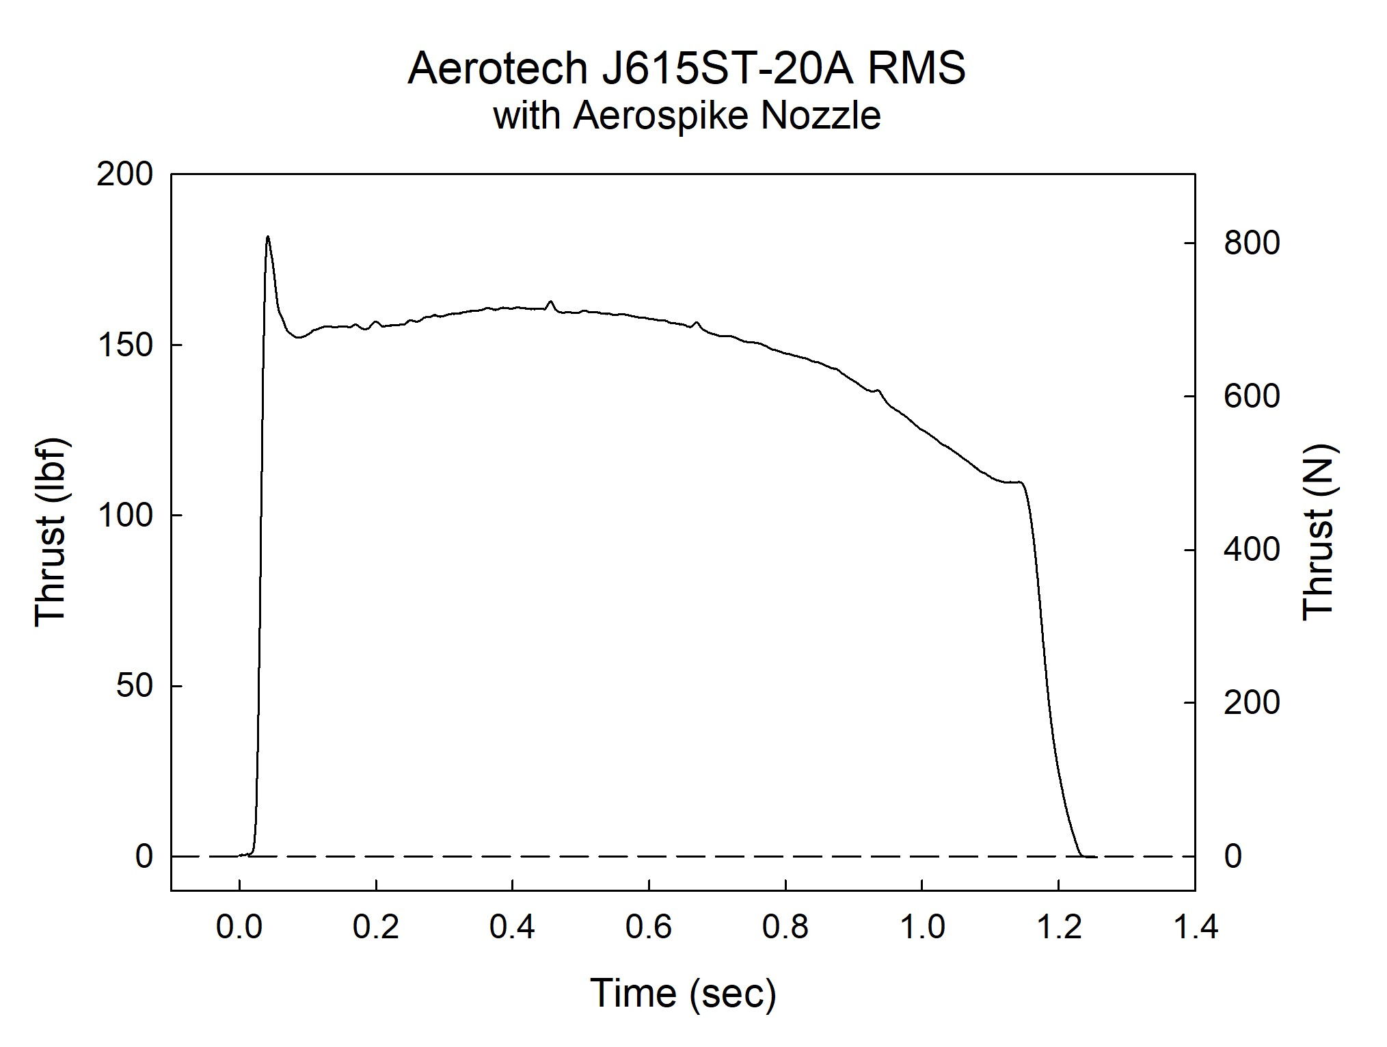

Sincerely,

Alan C. Whitmore
Chair, Tripoli Motor Testing

